Special Interim Report
Living Conditions and Infrastructure for Conscripts and Reservists – Visit by the State Comptroller to the Kfir Brigade Training Base in the Jordan Valley and the Yakir Outpost in Samaria
State Comptroller | October 2022

Special Interim Report – Living Conditions and Infrastructure for Conscripts and Reservists – Visit by the State Comptroller to the Kfir Brigade Training Base in the Jordan Valley and the Yakir Outpost in Samaria

On August 4, 2022, the State Comptroller and his team visited the Kfir Divisional Training Base in the Jordan Valley and the Yakir Outpost in Samaria. The visit took place as part of the audit being conducted at the IDF on living conditions and infrastructure for conscripts and reservists. The Kfir Divisional Training Base trains the brigade's fighters and commanders in the Jordan Valley. The Divisional Training Base has five companies in two camps – the Bkaot camp and the Peles camp. The Yakir Outpost is in Samaria, and during the State Comptroller's visit, a reserve battalion of the 300th Brigade was stationed while carrying out operational activity in the sector.
During the visit, the State Comptroller and his team examined the living conditions and infrastructure of the Kfir Brigade and the reserve battalion carrying out operational activity at the outpost. Also, they examined other topics, such as medical care and food. In addition to the meetings held by the State Comptroller with commanders in the divisional training base and the outpost, he met for a discussion at the Kafir Divisional Training Base with a group of conscripts and at the Yakir Outpost with a group of reservists.
The visit was conducted in the format of a "surprise audit"; therefore, the announcement regarding the planned visit was given to the IDF officials a few days before the visit.

hundreds |  | 42%$-$80% |  | 54%$-$69% |  | 0
of soldiers and commanders serve in the Kfir Army Divisional Training Base |  | soldiers rate whose satisfaction with the quality of food in the Kfir Divisional Training Base was 1$-$3 |  | soldiers rate whose level of satisfaction with the toilets and showers at the Kfir Divisional Training Base was 1$-$3 |  | no cold drinking water facilities in the company compounds in the Kfir Divisional Training Base
several weeks |  | 1 |  | about NIS 450,000 |  | about 70%
the time required to receive medical treatment according to 14 soldiers from Kfir Divisional Training Base (up to a few months for an orthopedist, three $-$ for receiving insoles, about two $-$ for a physical therapist and dental care) |  | the daily meat ration for each soldier |  | the renovation cost in 2022 in the kitchen and shading in the Kfir Divisional Training Base |  | the soldiers rate out of those called up who reported for reserve duty in the battalion stationed at the time of the visit at the Yakir Outpost

Key Findings

The Kfir Divisional Training Base
- Medicine $-$ by a conversation held by the State Comptroller with the soldiers, the medical treatment given to the soldiers is unsatisfactory. The fighters stated that, at times, weeks pass before they visit a doctor. Moreover, they said that, at times, many months pass from receiving the referral to a specialist doctor until meeting with them and addressing their medical problem. The fighters also noted that dentistry medical care is given after many weeks.
- Food and Water $-$ by the fighters' statements to the State Comptroller, the lunch menu includes plenty of carbohydrates. Still, the daily portion of meat is limited to one, resulting in insufficient meat portions. As a result, they do not receive the amount of protein required to be in shape and face physical challenges in training. In its response from September 2022, the IDF stated that the portion of meat served is adapted to nutritional requirements and that soldiers in the Kfir Divisional Training Base receive an additional portion of meat twice a week. The fighters also stated that maintaining personal hygiene and food hygiene is insufficient, sometimes affecting the soldiers' health and, as a result, their training. Furthermore, a tour of the Kfir Divisional Training Base raised that there are no cold drinking water facilities in the company complex, resulting in fighters often buying cold drinks from the vending machines, making do with drinking warm water from the taps or being forced to bring from the kitchen a cooler with ice to the training areas, located at a distance.
- The Training of Fighters $-$ the fighters stated in their discussion with the State Comptroller that although the training lasts eight months, the exhaustion time in the training is lacking, and logistical aspects take a significant part of the time.
- Living Conditions and Infrastructure $-$ by the State Comptroller and the audit team tour, deficiencies were found in the base infrastructures, mainly in Peles Camp's toilets, showers, and kitchen. The State Comptroller's conversation with the fighters raised living conditions and infrastructure numerous problems, especially the lack of shaded compounds and malfunctions in the air conditioners in the living barracks.

The Yakir Outpost
- The Value of Reserve Service $-$ commanders and reserve soldiers noted in the conversation with the State Comptroller that their employers were dissatisfied with their leaving for reserve duty for about three weeks. According to them, in the past, those going for reserve duty were respected, but currently, this has become a heavy burden on the relationship with the employer. This situation may harm employees who leave for reserve duty.
- Equipment $-$ by the conversations the State Comptroller held with the Battalion Commander and the reserve soldiers, the battalion lacks equipment used for its activities, especially certain weapons and designated vehicles. Moreover, armory management requires improvement, especially mechanized management of the records.
- Readiness $–$ a warning system was found to be malfunctioned and not working since the beginning of the battalion's activity. Following the State Comptroller's Office recommendation in the draft report that the IDF repair the warning system, the IDF replied in September 2022 that the system had been should repaired.
- Living Conditions and Infrastructure at the Yakir Outpost $-$ by the Battalion Commander and the reserve soldier's opinion in the conversations held with the State Comptroller, the main food problem was maintaining hygiene conditions. Moreover, due to the reinforcement of the Judea and Samaria with regular and reserve battalions beginning in April 2022 (as part of Operation "Breakwater"), which was still ongoing at the time of the visit, the kitchen at the outpost served two reserve battalions (instead of one battalion during routine times before reinforcements). This situation burdens the kitchen heavily and affects the ability to provide the optimal response to those serving in the outpost.

The Attitude of Commanders and Welfare Officials in the Kfir Divisional Training Base $-$ all the fighters taking part in the conversation with the State Comptroller commended the welfare officials at the divisional training base, who quickly and efficiently handle the soldiers' requests and who are attentive to the needs of populations defined as special populations in the IDF (among others, lone soldiers and immigrant soldiers). Many soldiers also commended the staff of commanders at the training base for being attentive and caring, which served as a personal example for most of them.
Dining Halls $-$ the dining hall infrastructure at the Kfir Divisional Training Base and the Yakir Outpost appeared in good condition. In 2022, the kitchen complex in the Bkaot camp at the Kfir Base was renovated at about NIS 300,000.

Key recommendations
- It is recommended that the IDF examine the medical response at the Kfir Divisional Training Base and formulate a plan according to the examination results. It is also recommended that the divisional training base ensure the proactive arrival of a doctor to training areas to improve the medical response in the field.
- It is recommended that the Technological and Logistics Directorate (Atal) address the protein deficiency and strict adherence to food hygiene to maintain the soldiers' fitness and health.
- It is recommended that the Kfir Divisional Training Base, in cooperation with the Ground Forces, address the deficiencies raised following the visit: in the infrastructure and their maintenance, improve conditions, especially air conditioning in the residences, shading complexes at the entrance to the dining hall and allocation of cold drinking water facilities to the company compounds.
- It is recommended that the Ground Forces examine the lack of equipment for the reserve force and consider how to fill the shortfall, with an emphasis on vehicles, including the implementation of the plan to improve the response to the maintenance of vehicles in the Central Command region and the allocation of dedicated medical vehicles to the reserve forces.
- It is recommended that the Technological and Logistics Directorate address the hygiene conditions in the kitchen at the outposts and ensure the guiding of the kitchen and dining hall staff in matters of food hygiene to maintain the health of both the conscripts and reserve soldiers.
- Given the reinforcement of the order of battle in Judea and Samaria as part of Operation "Breakwater," it is recommended that the IDF examine and map the need to improve the logistics supplies.

A Broken Window Without a Screen and a Rusted Ceiling in the Showers in the Kfir Base' Peles Camp

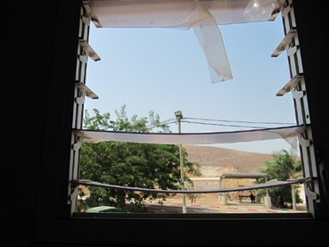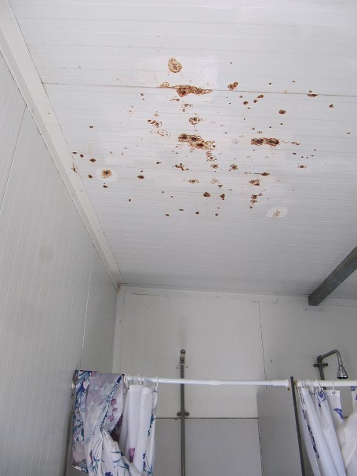
Photographed by the audit team on August 4, 2022.

Summary
In the course of the State Comptroller and his team's visit to the Kfir Divisional Training Base and the Yakir Outpost, the commanders and soldiers raised essential issues such as the training of the fighters, the value of reserve service, medical care, food, living conditions, and infrastructure. They also commended the attentive and caring attitude of the welfare personnel at Kfir Divisional Training Base and the command staff, which are a personal example to the fighters and specific infrastructures that have been improved. During the visit, the commanders and soldiers noted medicine, food, living conditions, and infrastructure deficiencies. The IDF should examine the findings raised during the visit and accordingly rectify them. Furthermore, given the reserve duty burden on the reservists' employment and their need for support dealing with their employers when going on reserve duty, it is recommended that the IDF act through the Ministry of Defense and cooperate with the relevant government ministries to address this issue. Thus, the reservists will be cherished, and their motivation to serve and contribute to the country $-$ maintained.

Between 1–5 in the questioners distributed by Kfir Divisional Training Base, 1 presents very low quality, 2 – low, 3 medium

