State Comptroller
Special Audit Report

The Prime Minister's Office Engagement with the Coordinator for Captives and Missing Persons

Jerusalem, January 2023

Catalog Number 001-2023
ISSN 0793-1947

This report is also available on the State Comptroller Office website
www.mevaker.gov.il

Compositor: Onit Computer Services Ltd.

The Prime Minister's Office Engagement with the Coordinator for Captives and Missing Persons

The captives and missing persons are a complicated issue that has been a cause for concern in Israel for decades. Addressing this issue involves, among other things, collecting information, managing contacts at the international level for achieving arrangements for the return of the captives and the missing persons, and keeping close contact with their families which are in a challenging period of an ongoing crisis. The Prime Minister's Office handles the captives and missing persons, and the Prime Minister is directly responsible for it. The Prime Minister's Office manages its activities regarding the captives and missing persons, also through the Captives and Missing Persons Coordinator (the Coordinator), who acts on behalf of the Prime Minister. The following figure presents some of the captives and missing persons' cases (both soldiers and civilians) for about 40 years since the beginning of the first Lebanon War in 1982.

Captives and Missing Persons Cases 1982$-$2022

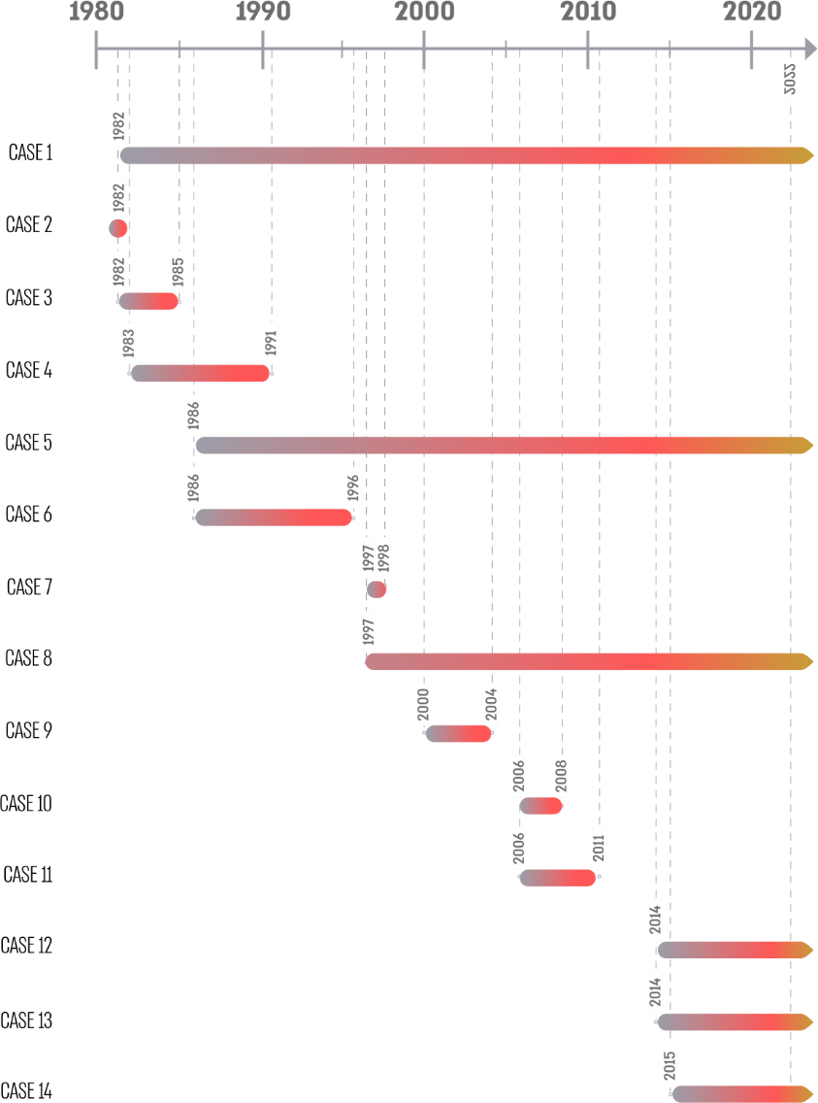
Source: data from IDF, EITAN (unit for detecting missing soldiers), and the Prime Minister's Office.

Audit Actions
From April to August 2022, the State Comptroller Office examined the engagement with the Captives and Missing Persons Coordinator. The audit included: addressing the recommendations of the committee for setting negotiating principles for captives' release headed by the former president of the Supreme Court, Meir Shamgar (the Shamgar Committee); defining the Coordinator's role, the expected outcomes, planning of his work, implementing work plans and reporting implementation; managing communication with families of captives and missing persons; managing information accumulated at the Prime Minister's Office; the Coordinator's engagement contract and payment for his work. This report does not deal with military-diplomatic actions and negotiations to form arrangements for the return of the captives and missing persons. The audit was conducted in the Prime Minister's Office, including the office of the Prime Minister's Military Secretary and the National Security Council. Supplementary audits were conducted in the IDF, the General Security Service, and the Israeli Secret Intelligence Service (Mossad).
This report was submitted to the Prime Minister on January 3rd, 2023, and confidentiality was imposed.
Under the authority vested upon the State Comptroller's Office by Section 17(c) of the State Comptroller Law 1958 [Consolidated Version], considering the government's arguments, consulting with the bodies in charge of the protection of national security information, coordination with the Chairman of the Knesset, and since the stated subcommittee failed to convene, it was decided to publish this report while imposing confidentiality on parts of it. These sections shall not be submitted to the Knesset, nor shall they be published.
The findings of the audit report and its recommendations are valid as of the above date of its presentation.

Key findings
- Addressing the Shamgar Committee's Recommendations $-$ in January 2012, the Shamgar Committee submitted its recommendations about the considerations, principles, and processes regulating the release of captives and missing persons on behalf of the state. The Committee's recommendations included reference to the organizational framework to manage captives and missing persons, the governmental entity addressing the issue directly and the formation and powers of a skilled team handling the issue constantly. In June 2014, the Shamgar Committee's recommendations were presented to the Ministerial Committee on National Security Affairs (the State Security Cabinet). According to the documents, the government, the Cabinet, or a different ministerial committee, held no additional discussions on the Shamgar Committee's recommendations and no decisions were made. This, despite the Prime Minister's guideline in 2014 to hold another discussion in Cabinet on the committee's recommendations; the position of the chairman of the Intelligence Subcommittee of the Knesset's Foreign Affairs and Defense Committee that a national policy on captives and missing persons is required, and that the Shamgar Committee's recommendations should not be abandoned; and the Coordinator's position to discuss the recommendations in the Cabinet.
- The Captives and Missing Persons Coordinator's Job Description $-$ throughout the years, the Coordinator has worked without the Prime Minister's Office specifying in the engagement contract his role, responsibilities, powers, and detailed scope of action. Moreover, the Prime Minister's Office has not determined the work interfaces between the Coordinator and the various security organizations or the means available to the Coordinator to perform his role, including the necessary manpower. The Shamgar Committee suggested a format to handle captives and missing persons. The government did not adopt the Committee's suggestion or create an alternative format.
- Planning the Coordinator's Work according to Work Plans and Reporting on Implementation $-$ the Prime Minister's Office engaged with the Coordinator without planning his duties and expected outcomes or creating flexible plans considering external factors that might affect his actions. The Prime Minister's Office did not have sufficient information to determine the extent to which the objectives of the Coordinator's work were met. Under these circumstances, without adequate planning and information, the Advisory Council of the Prime Minister's Office extended the engagement with the Coordinator four times. Even when the need arose to determine a work plan and metrics, the Council decided in October 2020 that the terms of engagement do not allow it. It was decided without considering establishing a work plan and metrics. However, a work plan was established in 2022.
- Managing Communication with Families of Captives and Missing Persons $-$ the Shamgar Committee pointed out the need to establish an official format for the communication between the Coordinator and the families. For years, the Prime Minister's Office has not established the communication format with the families and made do with determining that the Coordinator would be invited to all the meetings between the families and the heads of security organizations. One of the families contacted the Office of the State Comptroller and complained about the contents of the meetings with the Coordinator and the information he presented to them. The family described these meetings as "meaningless" and indicated that the Coordinator did not present any "significant information" about their efforts to bring back their loved one.
- Managing the Information Accumulated at the Prime Minister's Office $-$ the Shamgar Committee noted that organizational memory should be a professional basis for the teams working on captives and missing persons. However, organizational memory in this respect is somewhat limited. The Committee indicated the need for an orderly mechanism for accumulating knowledge to enable ongoing learning of past lessons and making conclusions for the future. According to the Committee, knowledge accumulated routinely might be useful for the involved parties when incidents related to captives and missing persons occur. There is a significant gap between the Shamgar Committee's position about maintaining organizational memory and the actual situation at the Prime Minister's Office: the considerable volume of information of the Prime Minister's Office and the Coordinator has not been formed into orderly knowledge accumulated throughout the years. Knowledge formation is needed in general and was particularly needed when the negotiation responsibility was given to the Prime Minister's representative, who is not a civil servant and is not part of a governmental unit that acts regularly, but rather a service provider who works with the government for a limited period.
- Engagement Contract and Payment for Work Performed by the Coordinator $-$ in three of the five engagement periods, the engagement had started before obtaining all the necessary approvals from the Advisory Councils. The actual engagement had started in four engagement periods before an agreement was signed with the Coordinator. The annual work hours of the Coordinator during the four first periods of engagement were from 1,900 to 2,200. The total sum paid to the Coordinator by the Prime Minister's Office for 4.5 years of service (from December 2017 to May 2022) was NIS 2.74 million (including VAT), an average of NIS 50,000 per month. The average monthly payment paid to the Coordinator by the Prime Minister's Office during the aforementioned period resembles a monthly salary paid to the director-general of a governmental ministry (including employer's provisions) at the time. The total of the Coordinator's approved work hours was $-$ 2,160 hours per year (180 monthly hours), similar to a full-time civil service employee (182 hours per month). The Coordinator reported an average of 165 work hours a month, an average of 20 workdays a month, and an average of 8 work hours a day, similar to a full-time civil service employee. For five years, the scope of the Coordinator's employment was not in line with the guidelines of the Civil Service Commission, according to which the Ministry that engages with an advisor must ensure that the advisor is not employed based on monthly hours similar to a civil servant's scope of employment. Moreover, the person in charge of the matter at the Prime Minister's Office and the legal advisor have not examined, as required, whether the engagement constitutes an employer-employee relationship. Out of the 55 months of work reported to the Prime Minister's Office by the Coordinator, reports of 30 months (55%) specified the tasks carried out by the Coordinator. The Prime Minister's Office paid the Coordinator for the work hours in all the reports.
The Coordinator initiated discussions with various entities and maintained a regular work team, including representatives from captives and missing persons units in different organizations.

Key recommendations
It is recommended that the Prime Minister's Office present to the government a format for handling captives and missing persons cases, including the ministry in charge.
It is recommended to determine the Coordinator's responsibilities and powers and work interfaces in detail, including receiving information from security organizations. Moreover, it is recommended that the Prime Minister's Office form a work plan for the Coordinator, including the different tasks assigned to him, metrics, and timetable, and follow up on the work plan's implementation. Suppose changes in the work plan are needed, such as changes in diplomatic or security circumstances. In that case, adjusting the plan to the new circumstances and following up on its implementation is recommended.
It is recommended that the Prime Minister's Office form a communication format between the Coordinator and the families of captives and missing persons, including the minimal frequency of meeting with the families and the person authorized to decide which information is presented to them. It is further recommended that the Prime Minister's Office consider periodically receiving information from the families of captives and missing persons about their communications with the Coordinator to ensure that the communication format is adequate.
It is recommended that the Prime Minister's Office form a mechanism for accumulating knowledge, including information about past lessons and their use by all relevant parties.
The Prime Minister's Office should act according to the Civil Service Commission guidelines $-$ approve the engagement with the Coordinator under the condition that the legal advisor and the person in charge of the matter on behalf of the Prime Minister's Office decide that the engagement does not constitute an employer-employee relationship or employment which is not in compliance with the Civil Service Law for Government Employees. As part of examining the engagement, the Prime Minister's Office should consider that the total work hours of the Coordinator and their distribution are similar to the total work hours of a full-time civil service employee. In addition, the Prime Minister's Office should ensure that the engagement with the Coordinator commences under the condition that the necessary decisions were made under the Mandatory Tenders Regulations, 1993, and under the condition that an agreement has been signed. It is also necessary to ensure that a complete report on the tasks carried out is a precondition for payment.

Periods of engagement and the date of signing the agreement and extending it

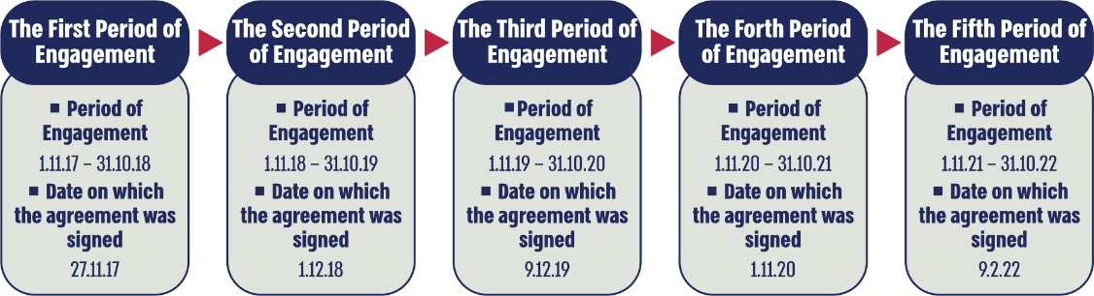

Summary
Contending with captives and missing persons throughout the years requires regulation of the activities also concerning the activities management on behalf of the prime minister or the government. In 2012, the Shamgar Committee pointed out some gaps in how the government addressed it. A decade has passed, and the government, the Minister of Defense who appointed the Committee or the Prime Minister's Office is in charge of the issue have made no decisions related to the Committee's recommendations. It is recommended that the Prime Minister's Office form a format for handling the captives and missing persons, determine the responsibilities and powers of the Coordinator, form a work plan including tasks, metrics, and timetable, and supervise the plan's implementation. It is further recommended that the Prime Minister's Office form the communication format between the Coordinator and the families of captives and missing persons, including the minimal frequency of meeting with them and the person authorized to decide which information is presented to them.

By the date of report completion, the Coordinator had been employed by the Prime Minster's Office for almost five years.

